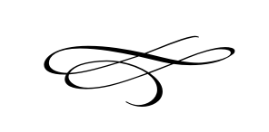
Charleston Planning Commission
Regular Meeting
January 23, 2020
7:00 pm
Charleston Town Hall
3454 West 3400 South, Charleston, Utah 84032

- Call to Order
- Opening Prayer
- Pledge of Allegiance
- Approval of Meeting Minutes For September 26th, 2019
- Public Comment- This is the time and place for any person who wishes to comment on items not scheduled on the agenda for public hearing. Any person or group wishing to comment on any item not otherwise scheduled for public hearing on the agenda may address the Planning Commission at this point by standing and giving his or her name for the record. Comments should be limited to not more than three (3) minutes, unless additional time is authorized by the governing body.

- Gary & Marilee Maxfield Proposal for Possible Annexation – Gary & Marilee Maxfield

- Alan Brown Application for Zone Change Continuation – Alan Brown

- Adjournment

