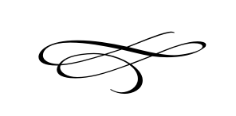

Charleston Planning Commission

Regular Meeting

May 24th, 2018

Meeting Canceled