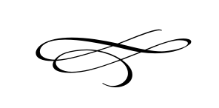

Charleston Planning Commission

Regular Meeting

June 28th, 2018

Regular Meeting

1. Call to Order
2. Opening Prayer
3. Public Comment:
4. Review & Approval of Meeting Minutes April - 2018
5. **Swearing in of Scott Keller New Planning Commission Member**- Clerk
6. **Site Plan Application Staker Parsen** - Grant Fowkes
7. Adjournment