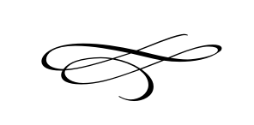

**Charleston Planning Commission**

**Regular Meeting**

October 25, 2018

**Cancelled due to lack of Agenda Items**



