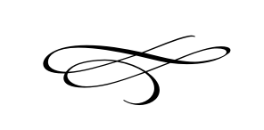

Charleston Planning Commission

Regular Meeting

December 27th, 2018

**No Meeting This Month**