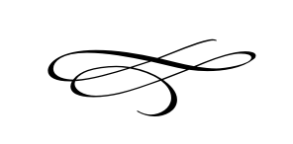

**Charleston Town Board**

**Meeting**

**Thursday – January 4th, 2018**

**7 p.m. – Town Hall**

1. Call to Order
2. Pledge of Allegiance
3. Opening Prayer
4. Swearing in of the New Mayor & Elected Board Members
5. Meeting Minutes and Financials for December 2017
6. Public Comment
7. Petition to Amend Charleston Plaza Subdivision - Tyler Dow
8. Resolution #2018-01 Meeting Schedule for 2018 – Mayor Kozlowski
9. Resolution #2018-02 Appointment of the New Treasurer – Mayor Kozlowski
10. Resolution #2018-03 Re-appointment of Deputy Treasurer –Mayor Kozlowski
11. Resolution #2018-04 Job Assignments for 2018 – Mayor Kozlowski
12. Clean-up Month Discussion – Mayor Kozlowski
13. Staff Reports
14. Adjournment