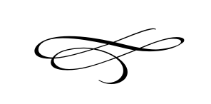

**Charleston Town Board**

**Meeting**

**Thursday – May 3rd, 2018**

**7 p.m. – Town Hall**

1. Call to Order
2. Pledge of Allegiance
3. Opening Prayer
4. Meeting Minutes and Financials for April 2018 – Mayor Kozlowski
5. Public Comment:
6. **Memorial Day Donation** – Adair Willoughby
7. **Soldier Hollow-Cross Walks & Signs** - Principal Morgan Murdock
8. **Concerts In The Park** – Jeff Whitley
9. **Proposed Alternate for Planning Commissio**n - Scott Keller – Mayor Kozlowski
10. **Oswald Petition to Annex into Charleston Possible Acceptance or Denial of Petition**  – Tyler Dow
11. **New Fee Schedule Resolution #2018-07** – Mayor Kozlowski
12. **Budget Amendment Discussion for Current Year** – Mayor Kozlowski
13. **Tentative Budget for Next Fiscal Year** – Mayor Kozlowski
14. Staff Reports:
15. Adjournment