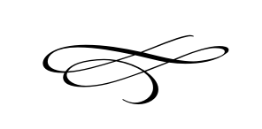

**Charleston Town Council**

**Meeting**

**Thursday – August 2nd, 2018**

**7 p.m. – Town Hall**

1. **Call to Order**
2. **Pledge of Allegiance**
3. **Opening Prayer**
4. **Approval Meeting Minutes July 2018** – Mayor Kozlowski
5. **Approval Monthly Financials July 2018**- Mayor Kozlowski
6. **Public Comment**:
7. **Public Hearing: Weathervane Site Plan Application Review and Potential**

**Approval–** Brian Preece and Ryan Taylor

1. **Public Project Financing Discussion –** Brian Preece and Laura Lewis
2. **Possible Sewer Discussion –** Mayor Kozlowski
3. **Water Issues Discussion -** Mayor Kozlowski
4. **Park Rental Contract Changes –**Mayor Kozlowski
5. **Staff Reports**:
6. **Adjournment**