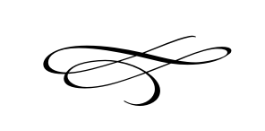

**Charleston Town Council**

**Meeting**

**Thursday – December 6th, 2018**

**7 p.m. – Town Hall**

1. **Call to Order**
2. **Pledge of Allegiance**
3. **Opening Prayer**
4. **Approval Meeting Minutes November 2018** – Mayor Kozlowski
5. **Approval Monthly Financials November 2018**- Mayor Kozlowski
6. **Public Comment**:
7. **Soldier Hollow School Signs –** Mayor Kozlowski
8. **Officials & Employee’s Thank You Dinner** – Mayor Kozlowski
9. **Staff Reports**:
10. **Adjournment**

