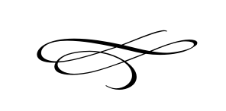

**Charleston Town Board**

**Meeting**

**Thursday – January 3rd, 2019**

**7 p.m. – Town Hall**

1. Call to Order
2. Pledge of Allegiance
3. Opening Prayer
4. Meeting Minutes for December 2018
5. Financials for December 2018
6. Public Comment
7. Ordinance # 2019-01 Plat Amendment For Weathervane Station, Vacating A

Portions of 2170 West – Brian Preece\Mike Johnston

1. Public Hearing For Weathervane Station Plat Amendment Application –

Brian Preece\Mike Johnston

1. Strong Vertical Gardens Default of Agreement Discussion – Mayor Kozlowski
2. Premises Occupation Discussion – Vaughn Rasband
3. Meeting Schedule for 2019 – Mayor Kozlowski
4. Board Assignments for 2019 – Mayor Kozlowski
5. Discussion of Assistant\Treasurer for 2019 – Mayor Kozlowski
6. Staff Reports
7. Adjournment