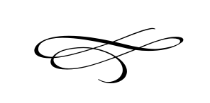
Charleston Town Board
Regular Meeting
Thursday – May 2nd, 2019
7 p.m. – Town Hall
- Call to Order
- Pledge of Allegiance
- Opening Prayer
- Approval of Meeting Minutes for April 2019 – Mayor Kozlowski
- Approval of Financials for April 2019 – Mayor Kozlowski
- Public Comment- This is the time and place for any person who wishes to comment on items not scheduled on the agenda for public hearing. Any person or group wishing to comment on any item not otherwise scheduled for public hearing on the agenda may address the Town Board at this point by standing and giving his or her name for the record. Comments should be limited to not more than three (3) minutes, unless additional time is authorized by the governing body.

- Recommendation from Planning Commission and Public Hearing on Land Use Ordinance on Section 02.90632 Premises Occupation - Brian Preece
- Public Hearing

- Blake Howell Subdivision, Summit Creek Final Plat Approval located at 3566 West 3000 South – Brian Preece and Blake Howell

- A Public Hearing To Receive Input From The Public With Respect To The Issuance of Charleston Town Sales and Franchise Tax Revenue Bonds, In One or More Series, In The Aggregate Principal Amount Not To Exceed $1,300,00 For Road Improvements, and Related Matters – Marc Edminster and Jeanette Johnson

- Wells Fargo Fees Verses Benefits – Mike Smith

- Staff Reports:
- Adjournment:

