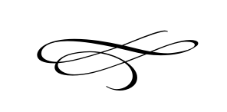
Charleston Town Board
Work Meeting

Wednesday – May 15th, 2019
8 a.m. – Town Hall

- Call to Order

- Pledge of Allegiance

- Opening Prayer

- Budgets 2020 and Budget 2019 Amendment – Mayor Kozlowski

- Special Tax Assessment – Mayor Kozlowski

- Property Tax Increase – Mayor Kozlowski

- General Plan – Mayor Kozlowski

- ULCT Mid-year Conference Review and Implementation – Mike Smith

- County Weed Report – Mike Smith

- Scout Project By Kayden Horner (Box Library) – Mayor Kozlowski

- Adjournment

